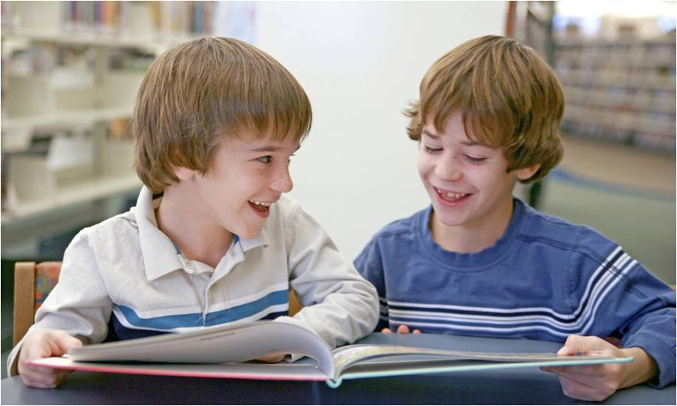
Mrs. Kohli’s -
“Super Star
Students”

Classroom Expectations:
Be RESPONSIBLE. | - Be prepared for class  - Complete and turn in assignments on time.  - Arrive on time for class.
Be RESPECTFUL. | - Raise your hand to speak.  - Be an attentive listener.  - Speak respectfully to others.  - Respect and follow classroom rules and procedures.  - Be kind to others.
Be POSITIVE. | - Follow directions quickly.  - Work together.  - Help your teachers and substitute teachers.
Be on TASK. | - Know what is expected and follow directions.
Be SAFE. | - Keeps hands, feet and objects to yourself.  - Push in chair.

